Lectures 5-6. Statistical inference.
Data performance in Excel

Table of content:

1. Inferential statistics
1.1. Frequency probability
1.2. Scope
1.3. Etymology
1.4. Alternative views
1.5. Bayesianism

2. Data performance in Excel

3. Home task

4. Picture 1

5. Picture 2

6. Picture 3

1. Inferential statistics or statistical induction comprises the use of statistics to make inferences concerning some unknown aspect of a population. It is distinguished from descriptive statistics. Two schools of inferential statistics are frequency probability and Bayesian inference. Statistical inference is inference about a population from a random sample drawn from it or, more generally, about a random process from its observed behavior during a finite period of time. It includes:
- point estimation
- interval estimation
- hypothesis testing (or statistical significance testing)
- dustihguish
There are several distinct schools of thought about the justification of statistical inference. All are based on some idea of what real world phenomena can be reasonably modeled as probability.
- frequency probability
- Bayesian probability Up
- fiducial probability
- eclectic probability
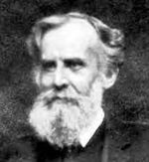
The topics below are usually included in the area of statistical inference.
- Statistical assumptions
- Likelihood principle
- Estimating parameters
- Statistical hypothesis testing
- Revising opinions in statistics
- planning statistical research
- summarizing statistical data

1.1. Frequency probability John Venn
Frequency probability is the interpretation of probability that defines an event's probability as the limit of its relative frequency in a large number of trials. The problems and paradoxes of the classical interpretation motivated the development of the relative frequency concept of probability. Most of the mathematics commonly used to make statistical estimates or tests are developed by statisticians who subscribe to this view of probability. They are usually called frequentists, and their position is called frequentism. This school is often associated with the names of Jerzy Neyman and Egon Pearson who described the logic of statistical hypothesis testing. Other influential figures of the frequentist school include John Venn, R.A. Fisher, and Richard von Mises. Frequentists talk about probabilities only when dealing with well-defined random experiments. The set of all possible outcomes of a random experiment is called the sample space of the experiment. An event is defined as a particular subset of the sample space that you want to consider. For any event only one of two possibilities can happen; it occurs or it does not occur. The relative frequency of occurrence of an event, in a number of repetitions of the experiment, is a measure of the probability of that event.
1.2. Scope Up
This is a highly technical and scientific definition and doesn't claim to capture all connotations of the concept 'probable' in colloquial speech of natural languages. Compare how the concept of force is used by physicists in a precise manner despite the fact that force is also a concept in many natural languages, used in religious texts for example. However, this seldom causes problem or confusion, as the context usually reveals if it's the scientific concept that is intended or not.
As William Feller noted:
There is no place in our system for speculations concerning the probability that the sun will rise tomorrow. Before speaking of it we should have to agree on an (idealized) model which would presumably run along the lines "out of infinitely many worlds one is selected at random..." Little imagination is required to construct such a model, but it appears both uninteresting and meaningless.

1.3. Etymology
According to the Oxford English Dictionary, the term 'frequentist' was first used by M. G. Kendall [1] in 1949, who observed
It might be thought that the differences between the frequentists and the non-frequentists (if I may call them such) are largely due to the differences of the domains which they purport to cover and went on to say. [2]. I assert that this is not so ... The essential distinction between the frequentists and the non-frequentists is, I think, that the former, in an effort to avoid anything savouring of matters of opinion, seek to define probability in terms of the objective properties of a population, real or hypothetical, whereas the latter do not. [emphasis in original]

1.4. Alternative views:

(Main article: Probability interpretations)

1.5. Bayesianism
The main alternative view, Bayesianism is more popular among decision theorists. Frequentists can't assign probabilities to things outside the scope of their definition. In particular, frequentists attribute probabilities only to events while Bayesians apply probabilities to arbitrary statements. For example, if one were to attribute a probability of 1/2 to the proposition that "there was life on Mars a billion years ago" one would violate frequentist canons, because neither an experiment nor a sample space is defined here. However, such degree-of-belief assignments of probability to statements are the basis of Bayesian probability theory.
Up

2. Data performance in Excel Up

2.1. Create an Excel table presented the diagrams (Picture 1) following master instructions.

2.2. Make notes about all the questions or problems you meet and how to manage that.

2.3. Make word document performance of the diagrams.

2.4. Answer the questions:
- how to add axis names?
- how to make two diagrams visible on the same field in Excel table?
- how to adjust diagram size?
- how to make diagram boxes dense?
- how to add boxes values?
- how to create a curve data approximation?
- how to export the Excel diagram into the Word document?
- how to make diagram picture moveable in the Word document?

3. Home task:

3.1. Create the Excel data performance for the people’s age distribution in Odessa city using the pattern given on the Picture 2 and Picture 3.

Up

4. Picture 1. Excel diagrams for salary frequency distribution Up

Salary up to: | 1- 300 | 301- 600 | 601-900 | 901-1200 | 1201-1500 | 1501-1800 | 1801-2100 | 2101-2400 | 2401-2700 | More 2700 | Sum %
F % | 8 | 18 | 24 | 20 | 15 | 7 | 3 | 2 | 2 | 1 | 100
Salary  up to: | 1- 150 | 151-300 | 301-450 | 451-600 | 601-750 | 751-900 | 901-1050 | 1051-1200 | 1201-1350 | 1351-1500 | 1501-1650
F % | 3 | 5 | 7 | 11 | 12 | 12 | 11 | 9 | 8 | 7 | 4
F / 0.5 | 6 | 10 | 14 | 22 | 24 | 24 | 22 | 18 | 16 | 14 | 8
5. Picture 2. Up

Nr. | 1 | 2 | 3 | 4 | 5 | 6 | 7 | 8 | 9 | 10 | 11 | 12
Weight (Kg) | 10 | 20 | 30 | 40 | 50 | 60 | 70 | 80 | 90 | 100 | 110 | 120 | Sum
F % | 20 |  |  | 25 |  |  | 30 |  |  | 25 |  |  | 100
F % | 9 | 11 |  | 12 | 13 |  | 14 | 16 |  | 13 | 12 |  | 100
F % | 6 | 7 | 7 | 8 | 8 | 9 | 10 | 11 | 9 | 9 | 9 | 7 | 100
 |  |  |  |  |  |  |  |  |  |  |  |  | 0
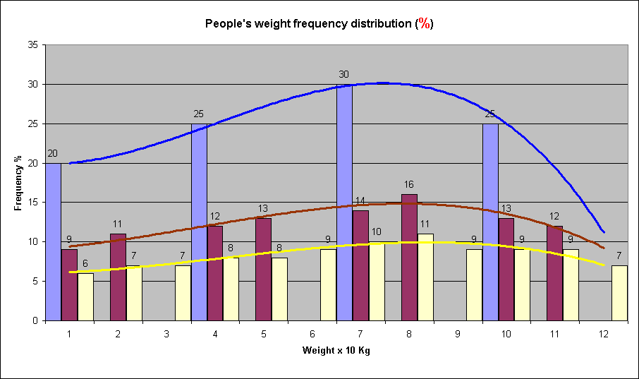

6. Picture 3. Up

Nr. | 1 | 2 | 3 | 4 | 5 | 6 | 7 | 8 | 9 | 10 | 11 | 12
Weight (Kg) | 10 | 20 | 30 | 40 | 50 | 60 | 70 | 80 | 90 | 100 | 110 | 120 | Sum
F (%) | 20 |  |  | 25 |  |  | 30 |  |  | 25 |  |  | 100
F / 0,5 | 18 | 22 |  | 24 | 26 |  | 28 | 32 |  | 26 | 24 |  | 200
F/0,333 | 18 | 21 | 21 | 24 | 24 | 27 | 30 | 33 | 27 | 27 | 27 | 21 | 300
 |  |  |  |  |  |  |  |  |  |  |  |  | 0
